CST1510 — Multi-Domain Intelligence Platform
Coursework 2 — Technical Report

Student Name | RAVELOMANANTSOA ANDONIAINA MALALA
Student ID | M01074169
Programme | BSc Computer Science
Module | CST1510 — Multi-Domain Intelligence Platform
Academic Year | 2025/26
GitHub Repository | https://github.com/malalarvl/CW2_M01074169_CST1510

Table of Contents
1. Introduction
2. System Architecture & Design
2.1 Security — Password Hashing & Authentication
2.2 Database Design & CRUD Operations
2.3 Application Architecture
2.4 Web Interface — Streamlit
2.5 AI Integration
3. Key Features & Implementation
3.1 User Authentication System
3.2 Cybersecurity Domain Dashboard
3.3 Data Science Domain Dashboard
3.4 IT Operations Domain Dashboard
3.5 AI Assistant
4. Testing & Validation
5. Reflection & Conclusion
5.1 What I Learned
5.2 Challenges Faced
5.3 Future Improvements
5.4 Conclusion
6. References

1. Introduction
The Multi-domain intelligence Platform is an application designed to integrate and manage information across cyber security incidents, IT operations and analytical datasets. Built with Streamlit, the application provides an accessible interface for users to monitor incidents, track tickets and review metadata in a dashboard.
The system is designed to solve common challenges such as managing varied datasets: weak authentication, lack of interactive visualization. With a secure user authentication, modular database design, the platform ensures both usability and data integrity.
In this report, the system architecture and design choices are firstly discovered then after the features and implementation, followed by testing and validation. Finally, discussion about reflections on the learning process, challenges faced, and future improvements.

2. System Architecture & Design

2.1 Security — Password Hashing & Authentication
.The platform uses ‘bcrypt’ to encrypt password. Indeed, bcrypt introduces a random salt for each password to ensure that identical passwords generate unique hashes. This prevents rainbow table attacks and strengthens resistance against brute-force attempts.
Two functions implement this mechanism:
- generate_hash(psw): converts plain text into a salted bcrypt hash.
- is_valid_hash(psw, hash): verifies user input against the stored hash using ‘bcrypt.checkpw()’,which perform as a timing-safe comparison
So this design ensures that users credentials are never stored in plain text.

2.2 Database Design & CRUD Operations
The system uses SQLite for lightweight and file based storage. Four table unpin the application:

TABLE | PURPOSE | KEY COLUMNS
users | Stores registered user accounts | id (PK), username (UNIQUE), password_hash, role
cyber_incidents | 115 cybersecurity incident records | incident_id, timestamp, severity, category, status, description
datasets_metadata | Registry of analytical datasets | dataset_id, name, source, size, last_updated
it_tickets | 150 IT support ticket records | ticket_id, priority, category, status, resolution_time
Table 1: SQlite Database Schema
CRUD operations are implemented in ‘users.py’ and parameterized queries prevent SQL injection, ensuring malicious inputs cannot alter database commands.

2.3 Application Architecture
The codebase follows a modular structure within the ‘app_model’ package:
This separation of concerns improve maintainability and scalability.Streamlit pages such as ‘Home.py’,’ ‘1_Dashboard.py’, ‘2_Profile_page.py’, ‘chat_GPT.py’ , interact with these modules, ensuring a clean architecture.
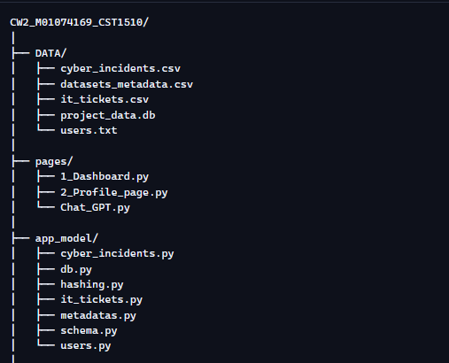
Figure 2: Architecture diagram

2.4 Web Interface — Streamlit
Streamlit was chosen because it allows users to build interactive web applications rapidly and easily using just Python. The application use a multi-page structure:
- ‘Home.py’ for login and registration
- ‘1_Dashboard.py’ for setting up dashboards
- ‘2_Profile_page.py’ for profile management
- ‘chat_GPT.py’ for implementing AI assistant
Session state (st.session_state) is a feature that enables to store and manage user_specific data throughout a session, it prevents unauthorized access to dashboards. Sidebar filters allow users to refine datasets, while ‘st.download_button’ enable exporting filtered results as CSV.

2.5 AI Integration
The AI assistant leverages the Groq/OpenAI Chat Completions API. Conversations are structured with three roles:
- System : defines domain restrictions(only project-related queries)
-User : submits prompts
-Assistant : generates responses
By embedding domain-specific system prompts, the chatbot ensures relevance and prevents off topic answers. Also conversation history is preserved in session state, enabling contextual dialogue.

3. Key Features & Implementation

3.1 User Authentication System
Feature: Secure login and registration with bcrypt
So firstly the user enters username and password then the password is checked again the stored hash using ‘is_valid_hash’. If valid , st.session_state[‘logged_in’] = True and username/role are stored
.Finally the user is sent to the dashboard.
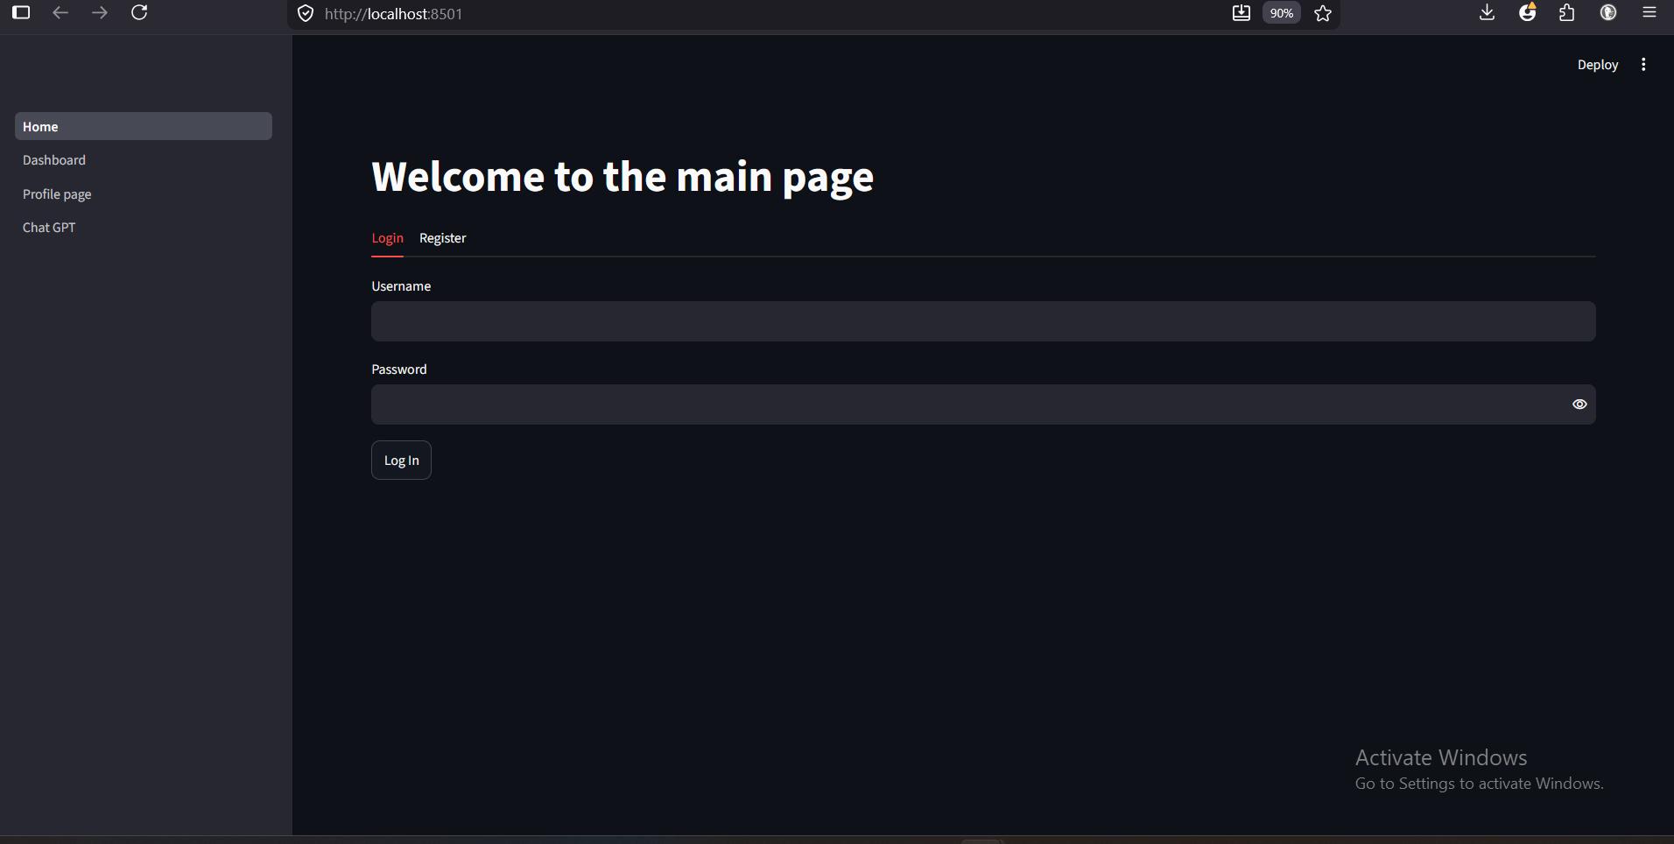
Figure 2: login form
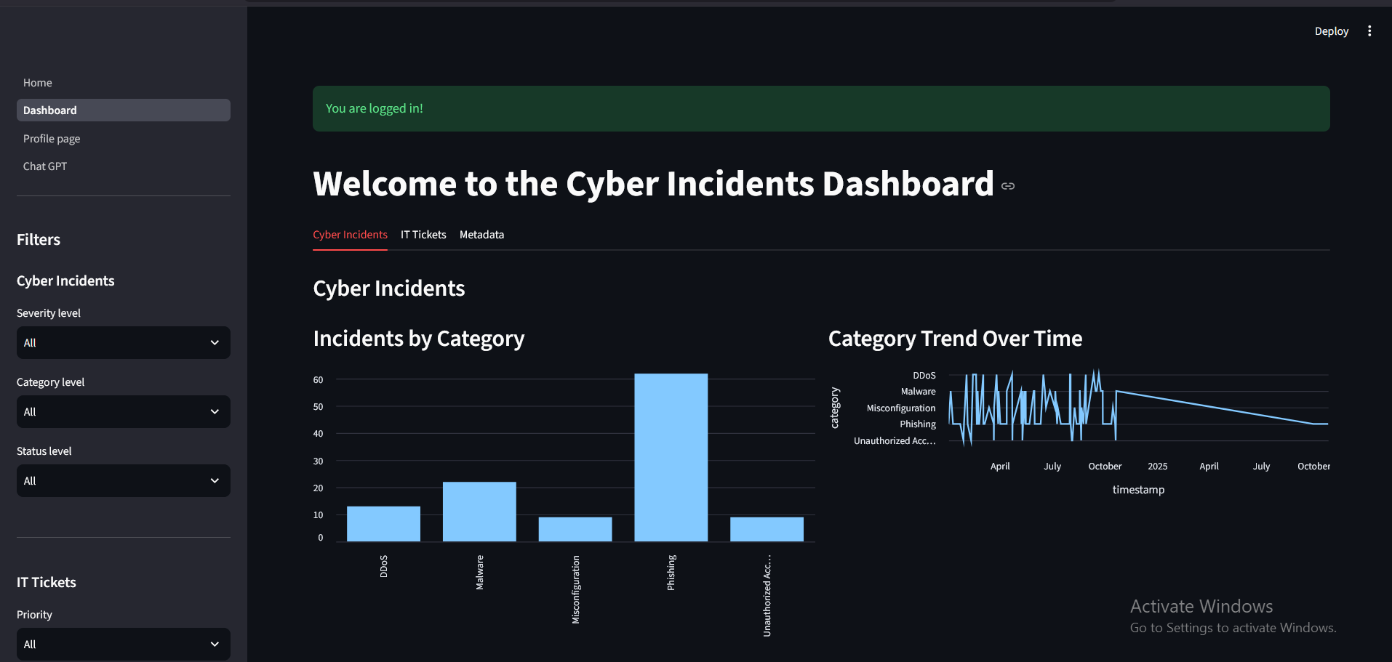
Figure 3: successful login

3.2 Cybersecurity Domain Dashboard
Feature : incident filtering by severity, category, status
In the cyber incident table the severity, category, status, timestamp are shown.
The data are retrived from SQLite via ‘get_all_cyber_incidents(conn)’ and displayed in streamlit
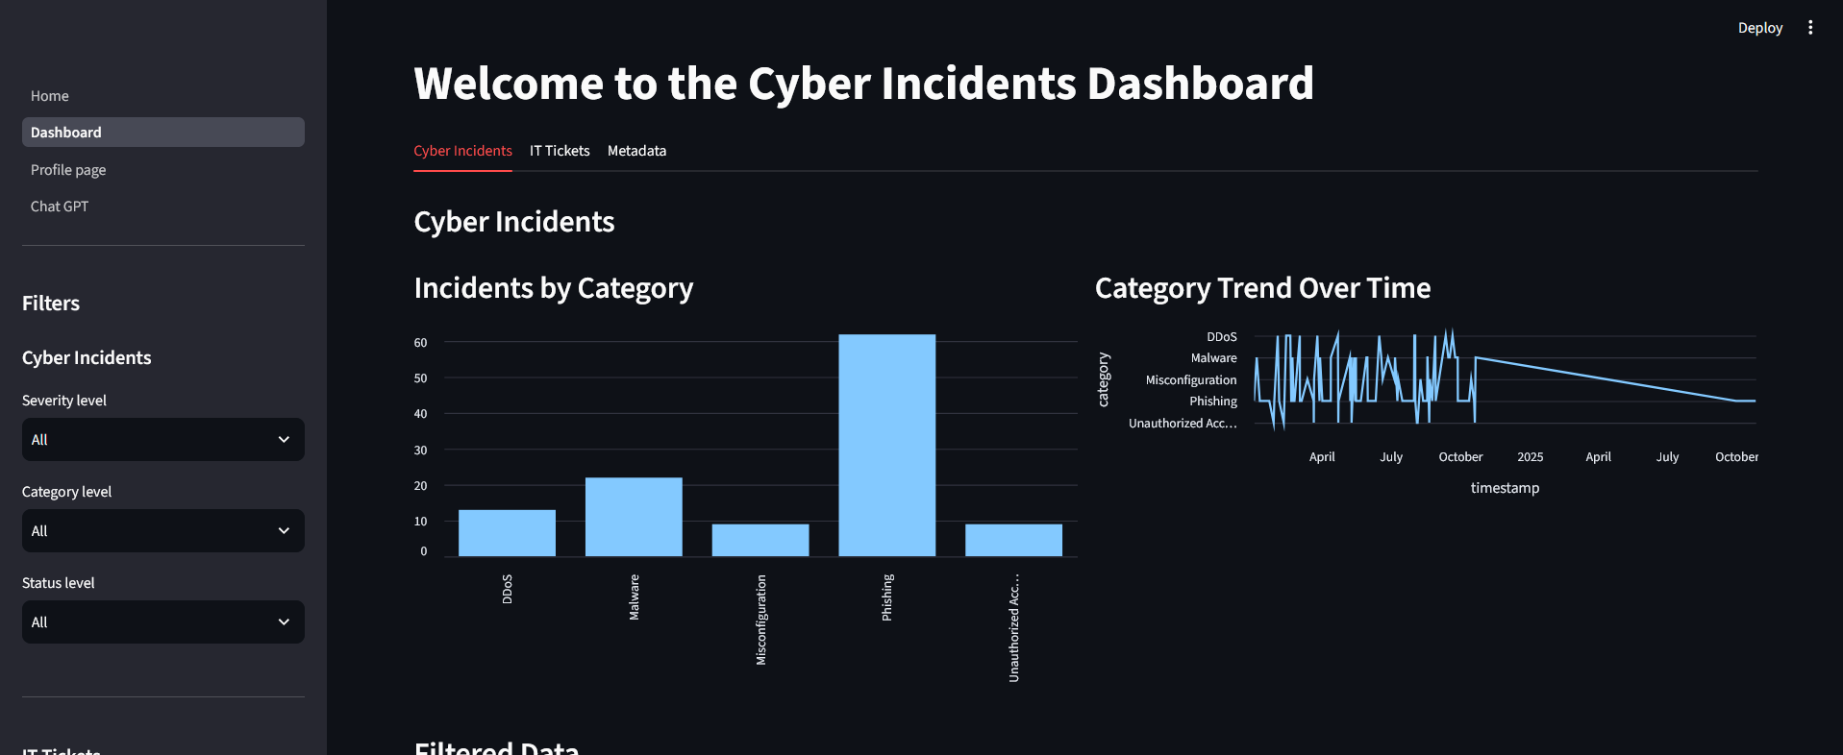
Figure 4: cyber incidents charts

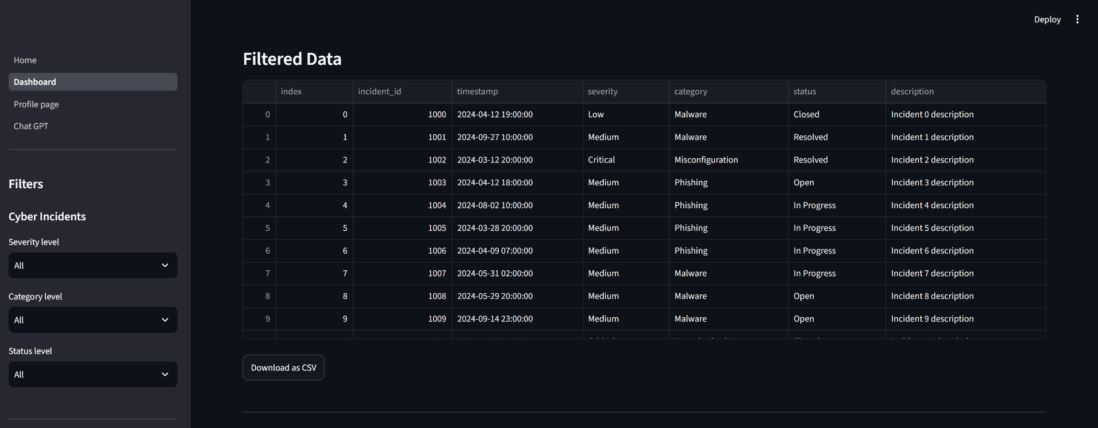
Figure 5: cyber incidents table

3.3 Data Science Domain Dashboard
Feature: Metadata registry display.
In the datasets table , name, source, size and last updated data are shown. It provides a registry of available datasets,helping users track dataset freshness and provenance.
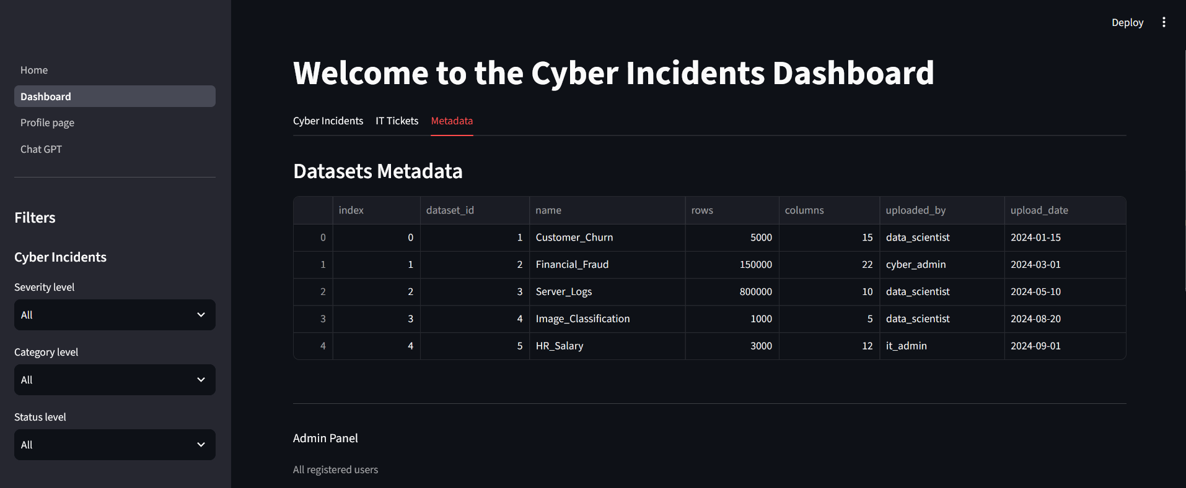
Figure 6: datasets table

3.4 IT Operations Domain Dashboard
Ticket management features:
-filters by priority and status
-bar chart shows tickets distribution by status
-table view lists ticket details
-download button allows exporting filtered tickets as CSV
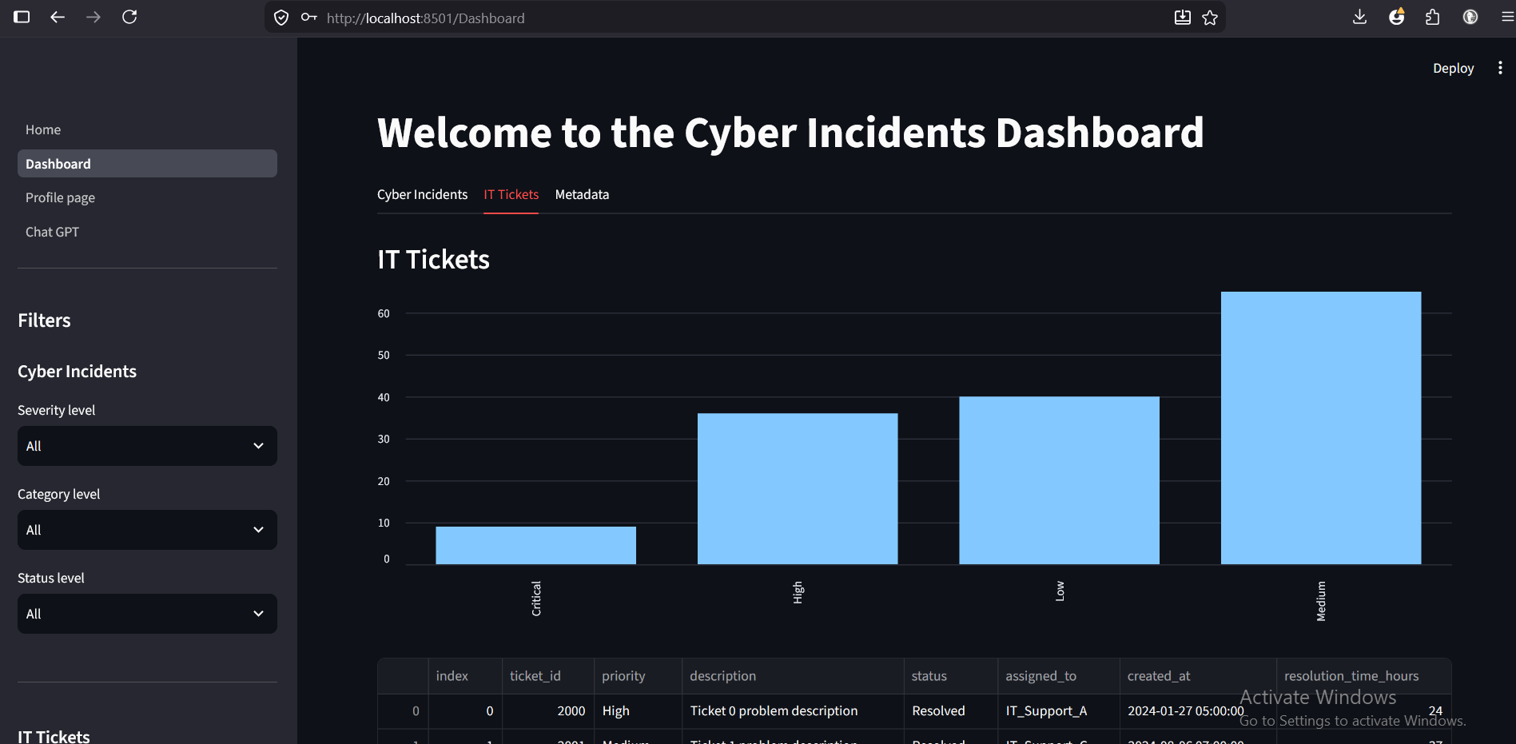
Figure 7: IT tickets priority chart
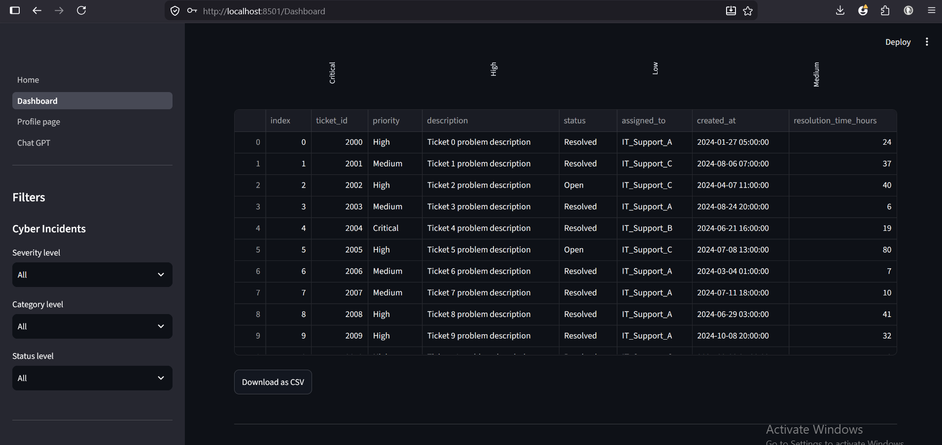
Figure 8: IT tickets table

3.5 AI Assistant
Feature : Domain restricted chatbot
This was use for the domain prompt:
“You are a helpfull assistant for this dashboard.
You can only answer questions about:
-How to use the application
-Cyber incidents data
-IT tickets data
-Datasets metadata
If asked anything unrelated, politely say:
'I can only answer question about this application and its data.”
This would restrict the system prompt and ensures the assistant only responds with project relevant knowledge.

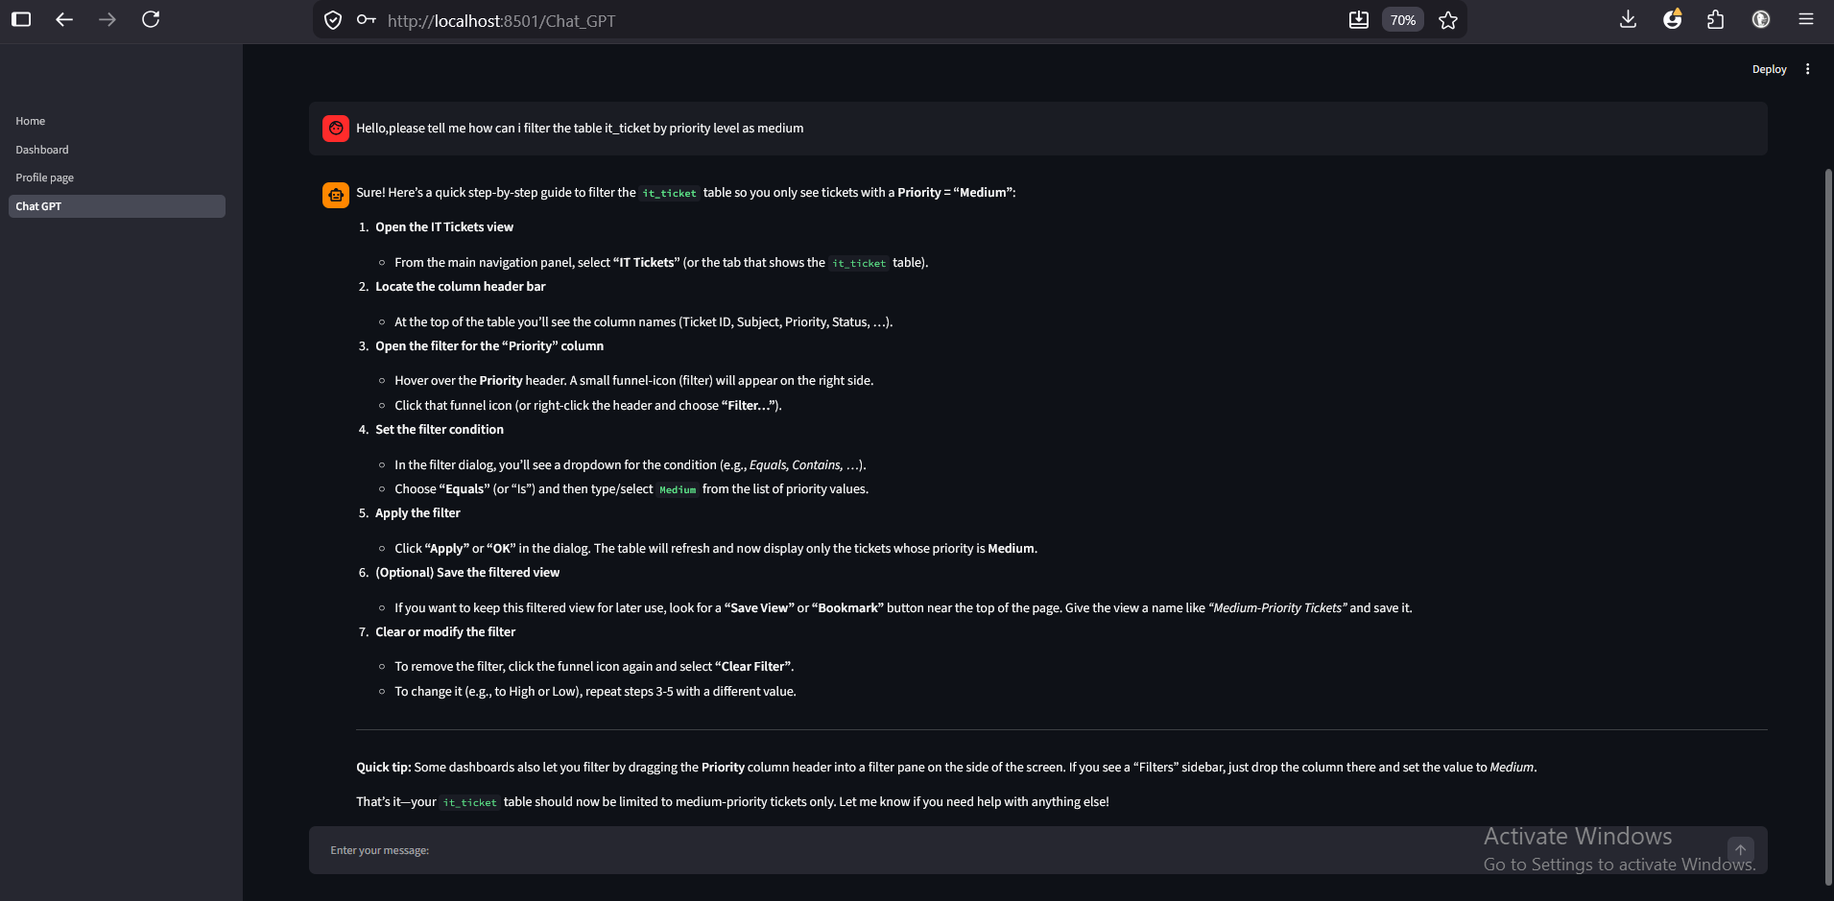
Figure 9: chat interface in action

4. Testing & Validation

TEST CASE | EXPECTED RESULT | ACTUAL RESULT
Login with correct credential | Success and redirected to dashboard | As expected result
Login as an admin | Admin panel shown | As expected result
Change password | Hash updated in database | As expected result
Download CSV | File save locally | As expected result
Delete user as an Admin | User deleted from database | As expected result
Button ‘My profile’ clicked | Page switched to ‘My profile’ | As expected result
AI assistant off topic query | Restricted response | As expected result
Admin try to delete themself | ‘Delete’ button disable | As expected result
Login with wrong password | Error message | As expected result
Table 2 : Testing and validation

5. Reflection & Conclusion

5.1 What I Learned
This project gave me hands on experience on several important areas of Python that I have not explored before.
Firstly, I learned that plain algorithms like MD5 and SHA-256 are insufficient to secure a password as they are too fast and vulnerable to rainbow table attacks. Therefore bcrypt is a better alternaltive as it adds unique random salt and slow to compute.
Furthermore, I highly enjoyed learning on how to built web page based application from python only and also using SQLite to design database schema and implement full CRUD operations.
Finally, integrating the Groq API taught me about API authentication,the messages list structure used by large language models and how system prompts can restrict AI behavior.

5.2 Challenges Faced
One of my greatest challenge was ‘how to set or update user role’ in the database. Initially the users table did not have a role column . So I tried to add it using ‘Alter table’ in the terminal then the role column was added but only for the existing user . Consequently , every new user are registered by default as ‘user’. To fix that if an user is an Admin, I created a new file ‘add_role.py’ that run in the console terminal to ask for the concerning user name and update the role to Admin.
Another difficulty that I faced was when GitHub rejected my push with the error ‘push declined due to repository rule violations’.GitHub’s scanning had detected the Groq API key hardcoded directly in the file ‘chat_GPT.py’.After researching I learned that hardcoding API keys in source code is a serious security risk. The solution was to remove the hardcoded key from the source code and delete the commit history using ‘git reset’ then force push the clean version to GitHub.

5.3 Future Improvements
Here are improvements to the platform that I would add if I had more time:
-A ‘forgot password’ features would reflect a real-world authentication system in case an user forgot their password to login
-When registering , make the new user able to choose a role and add a verification if they are admin
-The dashboard currently allow to view and filter data but not editing. Adding inline editing capabilities along side an audit log recording who changed what and when would make the platform more suitable for real operational use

5.4 Conclusion
The project successfully delivered a secure, modular and interactive intelligence platform. All requirements were met: authentication using bcrypt, AI assistant, dashboards where tabs of cyber incidents, datasets, IT tickets are display. The most important outcome was learning how to integrate multiple domains into a cohesive web application.

6. References
-Python Software Foundation (2024) Built-in Exceptions. Available at: https://docs.python.org/3/library/exceptions.html (Accessed:July 2026)
-Streamlit Inc.(2024) Streamlit documentation – st.selectbox. Available at:
https://docs.streamlit.io/develop/api-reference/widgets/st.selectbox (Accessed:July 2026)
- Streamlit Inc.(2024) Streamlit documentation- st.text_input. Available at:
https://docs.streamlit.io/develop/api-reference/widgets/st.text_input (Accessed:July 2026)
-Python Software Foundation (2024) sqlite3 – Parameterised queries. Available at:
https://docs.python.org/3/library/sqlite3.html#sqlite3-placeholders (Accessed:July 2026)
- Python Software Foundation (2024) sqlite3- Alter table. Available at:
https://docs.python.org/3/library/sqlite3.html (Accessed:July 2026)
- Streamlit Inc.(2024) Streamlit documentation-st.button. Available at:
https://docs.streamlit.io/develop/api-reference/widgets/st.button (Accessed:July 2026)
-Groq Inc.(2024) Groq API documentation- System prompts. Available at:
https://console.groq.com/docs/system-prompts (Accessed:July 2026)
-OpenAI (2024) Chat Completions – Message roles. Available at:
https://platform.openai.com/docs/guides/chat-completions (Accessed:July 2026)
- Streamlit Inc.(2024) Streamlit documentation-st.tabs . Available at:
https://docs.streamlit.io/develop/api-reference/layout/st.tabs (Accessed:July 2026)

